ICAR-ATARI, Pune
Name of KVK: Amravati I
Success story I. Special Project on cotton Kharif 2025-26
Name of KVK |  | Amravati I
Crop and Variety |  | Cotton – Ankur ARCH -3106
Name of farmer & Address |  | Shri. Dilip Sheshraoji Sukalkar, Warha, Ta.Teosa, Dist Amravati Mo. No.: 9423854101
Details of technology demonstrated |  | HDPS technology cotton sowing at 90 x 15 cm, which turn 20,320 plant population per acre
Institutional Involvement |  | Prior implementation of demonstration KVK has conducted group meeting and provided information about implementation of Demonstration. Before implementation provided training on cultivation practices of Cotton. Then trained to farmers for insect pest management and water management. After that we have organized field visit and diagnostic visit for resolving problem of farmers. Before harvesting conducted field day on same farmers field and showed to other farmers about performance of technology
Success Point |  | - Farmers got good yield (38.75 q/ha) which is 55 % more than Check Plot (25q/ha) under limited package of practices  - Fetches good price for crop (Rs.7750 /per quintal)  - Got Net Income of Rs. 162500/ha.
Farmer Feedback |  | - HDPS technology for cotton cultivation getting more yield  - Boll weight more than 4 gm that enhance cotton yield.  - Reduction of labour cost  - After harvesting of HDPS cotton by 150 days, second crop can be taken up in the rabi season (Chickpea, Wheat and Sesamum)
Yield (q/ha)
Demonstration | 38.75q/ha
Potential yield of variety/technology | 12-14 q/ha
District average | 6 q/ha (First advance Estimate during 2024)
State average | 4.22 q/ha (First Advance Estimate during the year 2024-25).
National average | -

Performance of technology vis-à-vis Local check (Increase in productivity and returns)
Practice used | Yield (q/ha) | Gross cost (Rs/ha) | Gross income (Rs/ha) | Net income (Rs/ha) | B:C ratio
Farmer practices | 25 | 80000 | 107500 | 27500 | 1.34
Demonstration | 38.75 | 124250 | 286750 | 162500 | 2.30
% Increase | 55

Photograph of Different activity conducted at Demonstration HDPS plot of Shri Dilip Sheshraoji Sukalkar under Special Project on Cotton
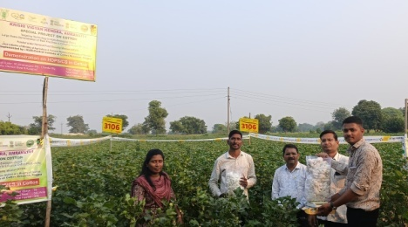 | 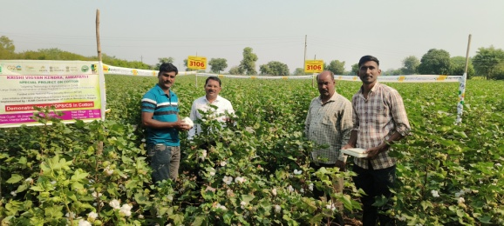
Crop Cut Under HDPS Cotton plot in presence of Shri Pramod Mendhe SMS Agronomy and Nodal officer, SPC, KVK, Ghatkhed and agriculture Assistant, Shri Nand Kishor Anasane along with Farmer and Yps.
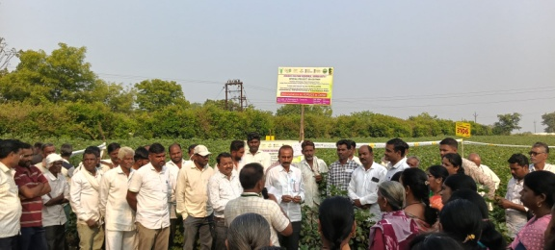 | 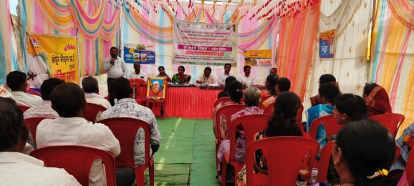
Dr. A. P. Kalsakar , Sr. Scientist and Head < kVk Gahtkhed Amravati and Shri P.N. Mendhe , SMS, Agronomy and District Nodal officer, Special project on Cotton , KVK Ghatkhed- Amravati. Discussing regarding crop condition during Field day prgrammeat Warha | Shri P.N. Mendhe, DNO, addressing the farmer during field day programme at HDPS demonstrated plot at warha

Name of KVK: Amravati I
Success story Special Project on cotton Kharif 2025-26
Name of KVK | Amravati I
Crop and Variety | Cotton, Variety – Kirti (Ankur Seeds Pvt ltd)
Name of farmer & Address | Shri. Ramdas Baliram Thavkar, Virul (Ronghe) Ta Dhamnagaon Rly, Dist Amravati Mo. No.9226715694
Details of technology demonstrated | CS technology cotton sowing at 90 x 30 cm, which turn 10560plant population per acre
Institutional Involvement | Prior implementation of demonstration KVK has conducted group meeting and provided information about implementation of Demonstration. Before implementation provided training on cultivation practices of Cotton. Then trained to farmers for insect pest management and water management. After that we have organized field visit and diagnostic visit for resolving problem of farmers. Before harvesting conducted field day on same farmers field and showed to other farmers about performance of technology
Success Point | - Farmers got good yield (35 q/ha) which is 55.50% more than Check Plot (22.5 q/ha) under limited package of practices  - Fetches good price for crop (Rs. 7500 /per quintal)  - Got Net Income OF Rs. 167250/ha
Farmer Feedback | - HDPS technology for cotton cultivation getting more yield  - Boll weight more than 4 gm that enhance cotton yield.  - Reduction of labour cost  - After harvesting of HDPS/CS cotton by 150 days, second crop can be taken up in the rabi season (Chickpea, Wheat and Sesamum)
Yield (q/ha)
Demonstration |  | 35 q/ha
Potential yield of variety/technology |  | 22.5 q/ha
District average |  | 9.20 q/ha (First advance Estimate during 2024)
State average |  | 9.04 q/ha (First Advance Estimate during the year 2024-25).
National average |  | -

Performance of technology vis-à-vis Local check (Increase in productivity and returns)
Practice used | Yield (q/ha) | Gross cost (Rs/ha) | Gross income (Rs/ha) | Net income (Rs/ha) | B:C ratio
Farmer practices | 22.5 | 82500 | 162000 | 79500 | 1.96
Demonstration | 35.00 | 95000 | 262500 | 167250 | 2.76
% Increase | 55.50

Photograph of Demonstration Closer Spasing plot of Ramdas Thavkar at Virul Ronghe ta : Dhamangaon under Special Project on Cotton
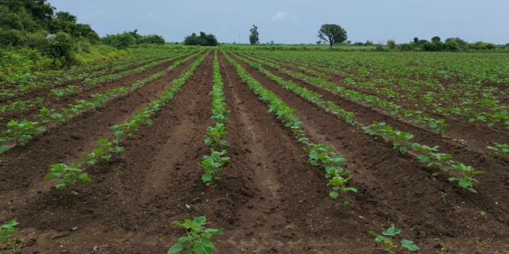 | 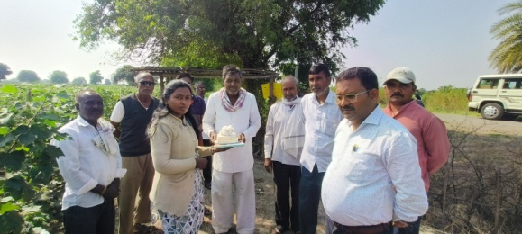
Germination of Crop after Sowing on Bed of Demonstration Plot | Visit of Shri P. N. Mendhe , SMS Agronomy and DNO to Demonstration plot
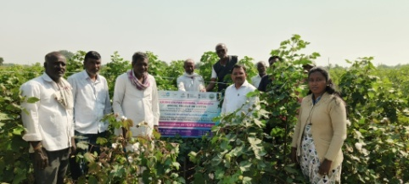 | 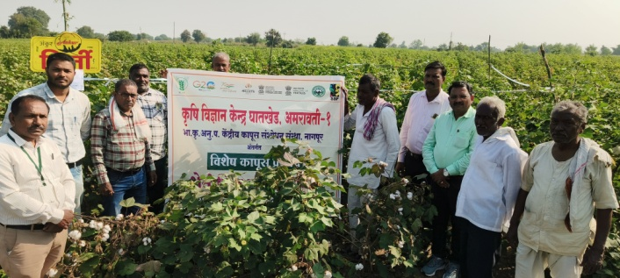
Crop Cut in presence of DNO and Progressive farmer of Village | Visit of Dr. A. P. Kalskar , Sr. Scientist and Head, KVK to Demonstration plot and discussing with farmers about performance of crop under Special Project on Cotton

Name of KVK: Amravati I
Success story of Special Project on cottonKharif 2025-26
Name of KVK |  | Amravati I
Crop and Variety |  | Cotton Variety – Kirti (Ankur Seeds Pvt ltd)
Name of farmer & Address |  | Shri Surendra Bajrangsingh Bais, Shirajgaon Korde, Ta.Chandur railway, Dist Amravati Mo No.: 7498777813
Details of technology demonstrated |  | Closer Spacing technology cotton sowing at 90 x 30 cm, which turn 11360 plant population per acre
Institutional Involvement |  | Prior implementation of demonstration KVK has conducted group meeting and provided information about implementation of Demonstration. Before implementation provided training on cultivation practices of Cotton. Then trained to farmers for insect pest management and water management. After that we have organized field visit and diagnostic visit for resolving problem of farmers. Before harvesting conducted field day on same farmer’s field and showed to other farmers about performance of technology.
Success Point |  | - Farmers got good yield (32.2 q/ha) which is 62.5% more than Check Plot ( 20q/ha) under limited package of practices  - Fetches good price for crop (Rs. 8100/per quintal)  - Got Net Income of Rs. 164500 /ha
Farmer Feedback |  | - CS technology for cotton cultivation getting more yield  - Boll weight more than 4 gm that enhance cotton yield.  - Reduction of labour cost  - After harvesting of CS cotton by 150 days, second crop can be taken up in the rabi season (groundnut).
Yield (q/ha)
Demonstration | 32.5q/ha
Potential yield of variety/technology | 11 -14 q/ha
District average | 6 q/ha (First advance Estimate during 2024)
State average | 4.12 q/ha (First Advance Estimate during the year 2024-25).
National average | -

Performance of technology vis-à-vis Local check (Increase in productivity and returns)
Practice used | Yield (q/ha) | Gross cost (Rs/ha) | Gross income (Rs/ha) | Net income (Rs/ha) | B:C ratio
Farmer practices | 20 | 82500 | 148000 | 65500 | 1.79
Demonstration | 32.5 | 98750 | 263250 | 164500 | 2.66
% Increase | 62.50

Photograph of Demonstration plot of Shri Surendra Bajanrangsing Bais under Special Project on Cotton 2025-26
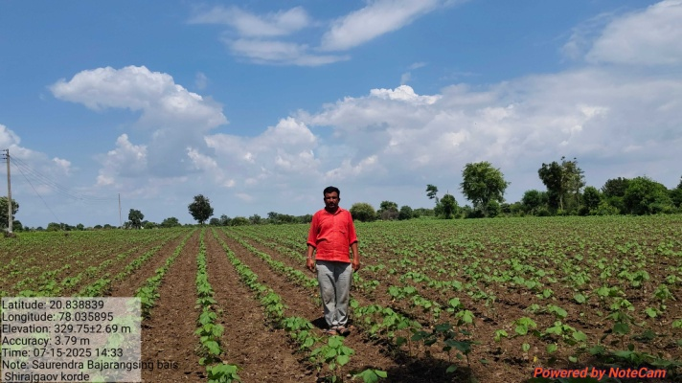 | 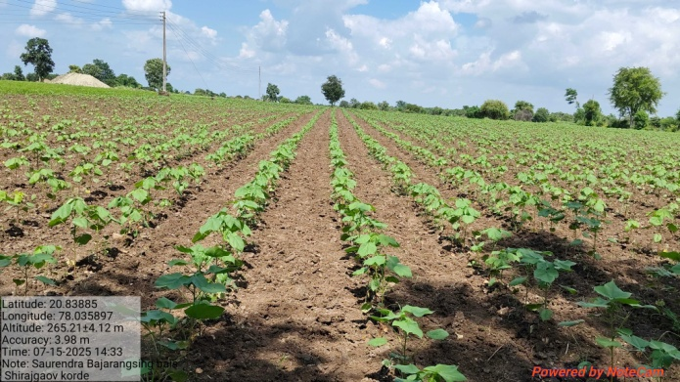
A view of closer spacing demonstration plot with farmer Shri Surendra Bais
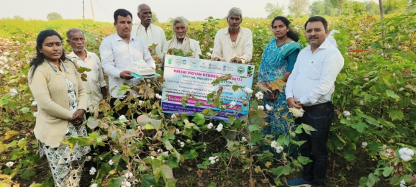 | 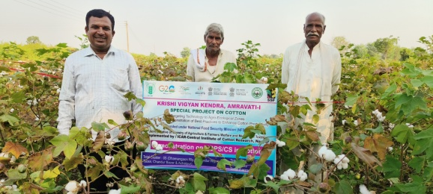
Crop Cut Under HDPS Cotton plot in presence of Shri Pramod Mendhe SMS Agronomy and Nodal officer, SPC, KVK, Ghatkhed and Sau Sangita Badre, Upsarpanch, ShirajgaonKorde, along with Farmer and Yps under Special Project on cotton. | A view of closer spacing demonstration plot with farmer Shri Surendra Bais along with farmers

Name of KVK: Amravati I
Success story Special Project on cotton Kharif 2025-26
Name of KVK |  | Amravati I
Crop and Variety |  | Cotton Variety – Kirti (Ankur Seeds Pvt ltd)
Name of farmer & Address |  | Shri Baban Bapurao Badre, Warha, Ta.Teosa, Dist Amravati Mo No.:
Details of technology demonstrated |  | CS technology cotton sowing at 90 x 30 cm, which turn 12800 plant population per acre
Institutional Involvement |  | Prior implementation of demonstration KVK has conducted group meeting and provided information about implementation of Demonstration. Before implementation provided training on cultivation practices of Cotton. Then trained to farmers for insect pest management and water management. After that we have organized field visit and diagnostic visit for resolving problem of farmers. Before harvesting conducted field day on same farmers field and showed to other farmers about performance of technology
Success Point |  | - Farmers got good yield (35q/ha) which is 81.81% more than Check Plot (23.75q/ha) under limited package of practices  - Fetches good price for crop (Rs. 7500/per quintal)  - Got Net Income of Rs. 167500/ha
Farmer Feedback |  | - CS technology for cotton cultivation getting more yield  - Boll weight more than 4 gm that enhance cotton yield.  - Reduction of labour cost  - After harvesting of CS cotton by 150 days, second crop can be taken up in the rabi season (groundnut)
Yield (q/ha)
Demonstration | 35q/ha
Potential yield of variety/technology | 11 -14 q/ha
District average | 6 q/ha (First advance Estimate during 2024)
State average | 4.12 q/ha (First Advance Estimate during the year 2024-25).
National average | -

Performance of technology vis-à-vis Local check (Increase in productivity and returns)
Practice used | Yield (q/ha) | Gross cost (Rs/ha) | Gross income (Rs/ha) | Net income (Rs/ha) | B:C ratio
Farmer practices | 19.25 | 83750 | 136675 | 52925 | 1.63
Demonstration | 35 | 95000 | 262500 | 167500 | 2.76
% Increase | 81.81

Photograph of Demonstration plot of Shri Baban Bapurao Badre under Special Project on Cotton
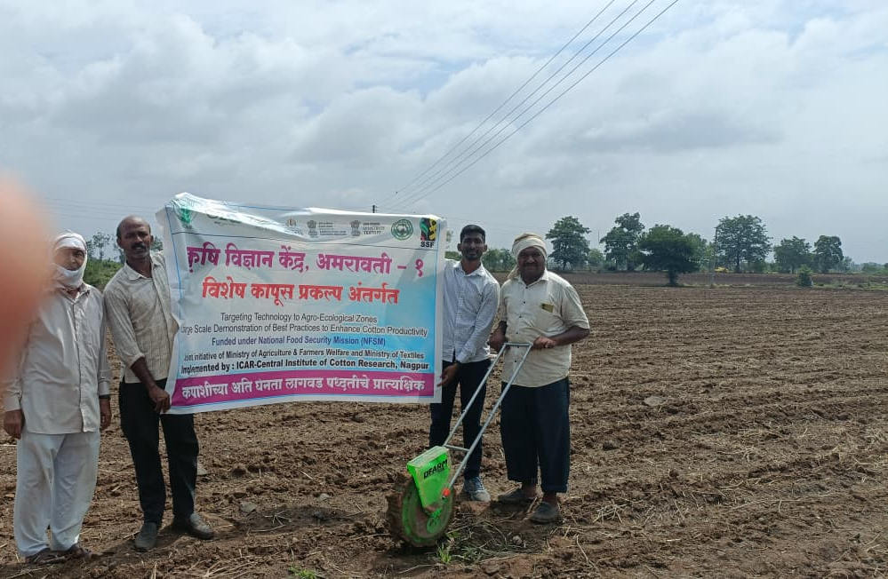 | Soeing of 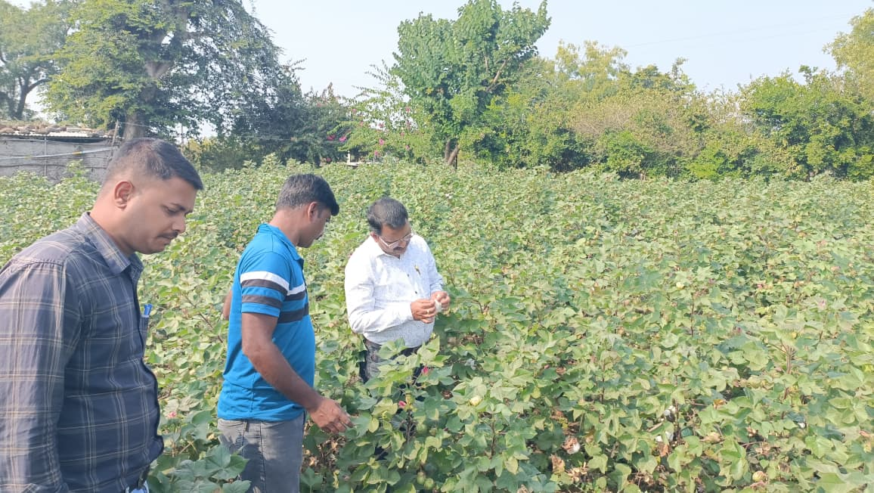
Sowing of cotton on bed by Manual Operated Seed drill Machine for maintaining proper Distance of Sowing 90 x 30 cm | Dignostic Visit of Shri P. N. Mendhe, SMS and DNO SPC during Boll development stage to Demonstration Plot
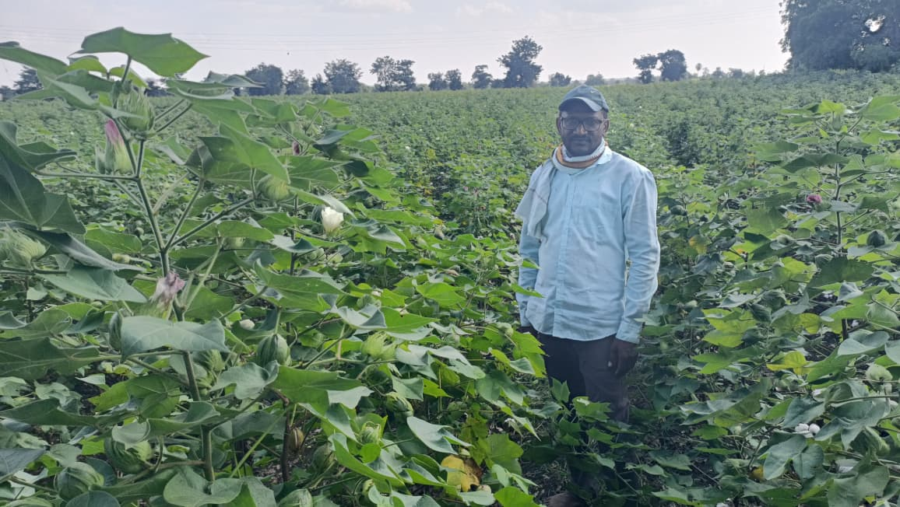 | 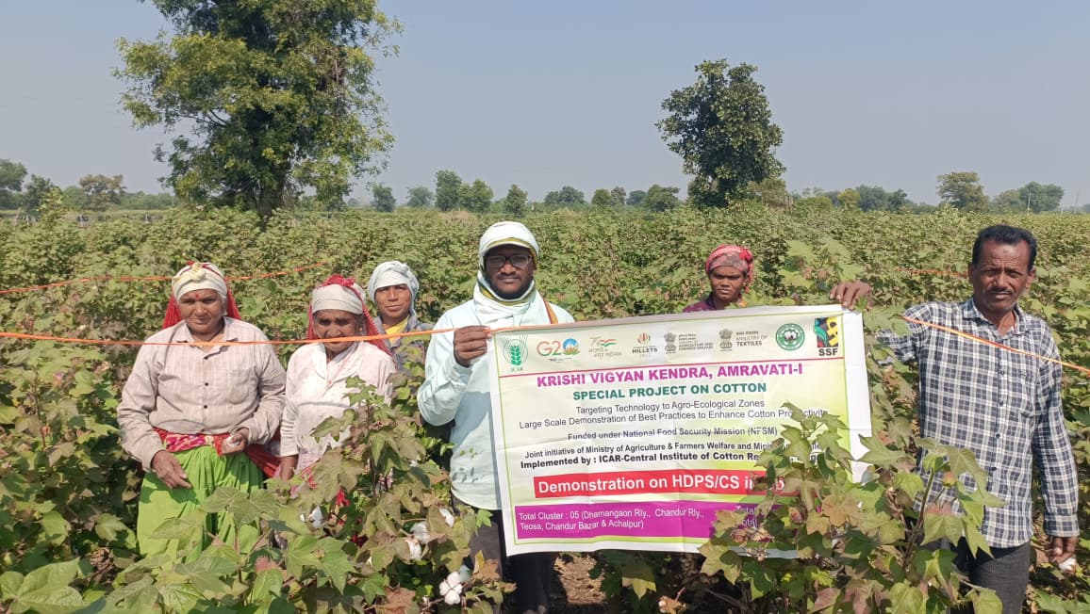
A view of closer spacing demonstration plot with farmer Shri Baban Bapurao Badre along with farmers.

Name of KVK: Amravati I
Success story Special Project on cottonKharif 2025-26
Name of KVK |  | Amravati I
Crop and Variety |  | Cotton Variety – Kirti and 3106 (Ankur Seeds Pvt ltd)
Name of farmer & Address |  | Shri Vijay G. Tamhane, Kharda, Ta.Dhamnagaon Railway Dist Amravati Mo No.:7720833246
Details of technology demonstrated |  | CS technology cotton sowing at 90 x 30 cm, which turn 13280 plant population per acre
Institutional Involvement |  | Prior implementation of demonstration KVK has conducted group meeting and provided information about implementation of Demonstration. Before implementation provided training on cultivation practices of Cotton. Then trained to farmers for insect pest management and water management. After that we have organized field visit and diagnostic visit for resolving problem of farmers. Before harvesting conducted field day on same farmers field and showed to other farmers about performance of technology
Success Point |  | - Farmers got good yield (32.5 q/ha) which is 73.33% more than Check Plot (23.75 /ha) under limited package of practices  - Fetches good price for crop (Rs. 7700/per quintal)  - Got Net Income of Rs. 139875/ha
Farmer Feedback |  | - CS technology for cotton cultivation getting more yield  - Boll weight more than 4 gm that enhance cotton yield.  - Reduction of labour cost  - After harvesting of CS cotton by 150 days, second crop can be taken up in the rabi season (groundnut)
Yield (q/ha)
Demonstration | 32.5 q/ha
Potential yield of variety/technology | 11 -14 q/ha
District average | 6 q/ha (First advance Estimate during 2024)
State average | 4.12 q/ha (First Advance Estimate during the year 2024-25).
National average | -
Performance of technology vis-à-vis Local check (Increase in productivity and returns)
Practice used | Yield (q/ha) | Gross cost (Rs/ha) | Gross income (Rs/ha) | Net income (Rs/ha) | B:C ratio
Farmer practices | 18.75 | 84500 | 135500 | 51000 | 1.60
Demonstration | 32.5 | 98970 | 250250 | 151280 | 2.52
% Increase | 73.33

Photograph of Demonstration plot of Shri Vijay Tamhne under Special Project on Cotton
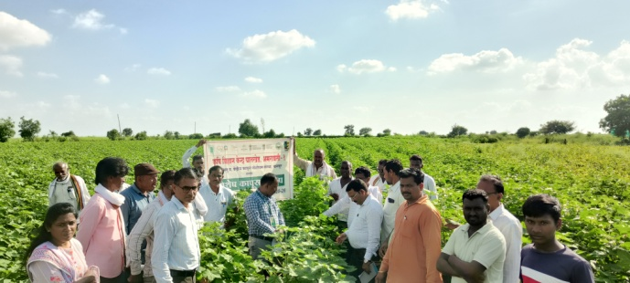 | 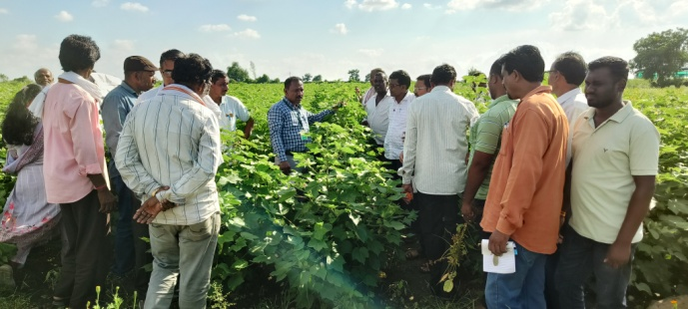
Dr. A. P. kalsakar and team of KVk Scientist discussing with farmers about cultivation practices with farmer during Field visit to Plot of Shri Vijay Thamnae at Boll Formation stage | Dr. A. P. kalsakar and team of KVK Scientist discussing with farmers about cultivation practices with farmer during Field visit to Plot of Shri Vijay Thamnae at Boll Development stage
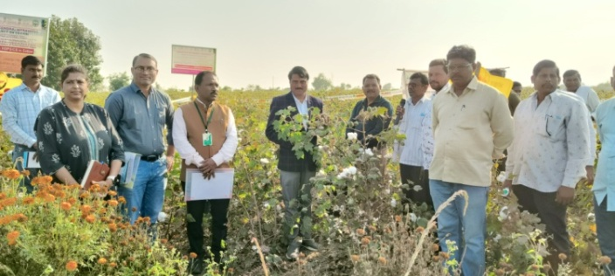 | 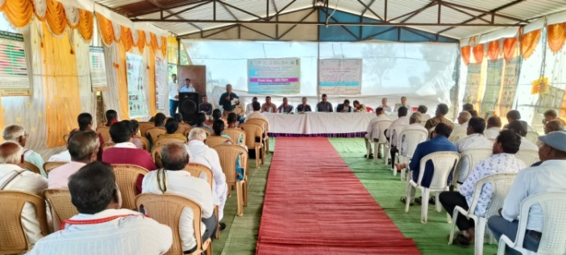
Honble Adv. Nilesh Helonde Patil, Chairman VNSSM M.S. addressing the farmer during field visit of field day programme on field of Shri Vijay Tamhane | Shri P. N. Mendhe SMS, Agronomy, DNO, SPC, KVK, Ghatkhed, Amravati. Guidance to farmers during field day prgramme at village Kharda.

Name of KVK: Amravati I
Success story Special Project on cotton Kharif 2025-26

Name of KVK |  | Amravati I
Crop and Variety |  | Cotton Variety – Kirti (Ankur Seeds Pvt ltd)
Name of farmer & Address |  | Shri Prashant Sudhakar Isad, Warha, Ta.Teosa, Dist Amravati Mo No.: 9665113633
Details of technology demonstrated |  | HDPS technology cotton sowing at 90 x 15 cm, which turn 16480 plant population per acre
Institutional Involvement |  | Prior implementation of demonstration KVK has conducted group meeting and provided information about implementation of Demonstration. Before implementation provided training on cultivation practices of Cotton. Then trained to farmers for insect pest management and water management. After that we have organized field visit and diagnostic visit for resolving problem of farmers. Before harvesting conducted field day on same farmers field and showed to other farmers about performance of technology
Success Point |  | - Farmers got good yield (36.65q/ha) which is 85.56% more than Check Plot (19.75 q/ha) under limited package of practices  - Fetches good price for crop (Rs. 7600/per quintal)  - Got Net Income of Rs. 78960 /ha
Farmer Feedback |  | - CS technology for cotton cultivation getting more yield  - Boll weight more than 4 gm that enhance cotton yield.  - Reduction of labour cost  - After harvesting of CS cotton by 150 days, second crop can be taken up in the rabi season (groundnut)
Yield (q/ha)
Demonstration | 36.65q/ha
Potential yield of variety/technology | 11 -14 q/ha
District average | 6 q/ha (First advance Estimate during 2024)
State average | 4.12 q/ha (First Advance Estimate during the year 2024-25).
National average | -

Performance of technology vis-à-vis Local check (Increase in productivity and returns)
Practice used | Yield (q/ha) | Gross cost (Rs/ha) | Gross income (Rs/ha) | Net income (Rs/ha) | B:C ratio
Farmer practices | 19.75 | 81500 | 150100 | 68600 | 1.84
Demonstration | 36.65 | 106500 | 278540 | 78960 | 2.26
% Increase | 85.56

Photograph of Demonstration plot of Shri Prashant Isad under Special Project on Cotton
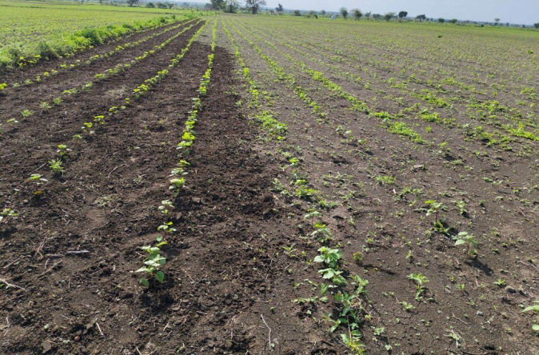 | 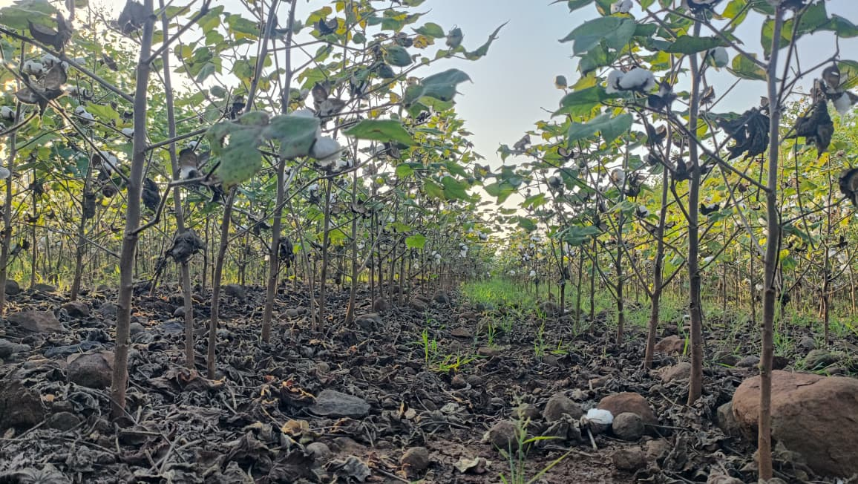
A View of Demonstration plot after germination of crop | Planting of crop at proper distance at 90x15 cm for maintaining proper plant population
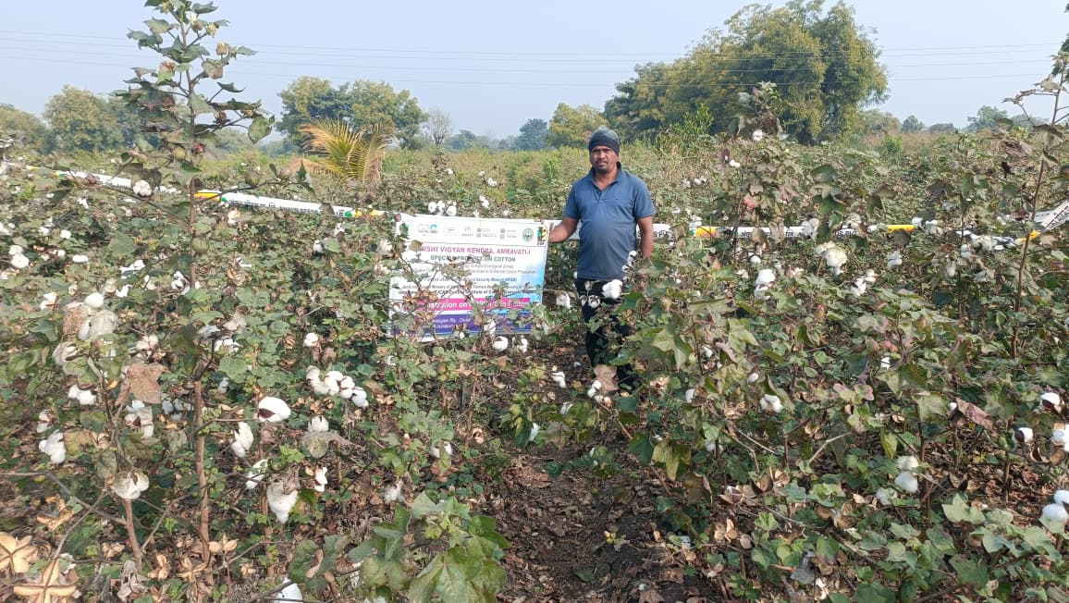 | 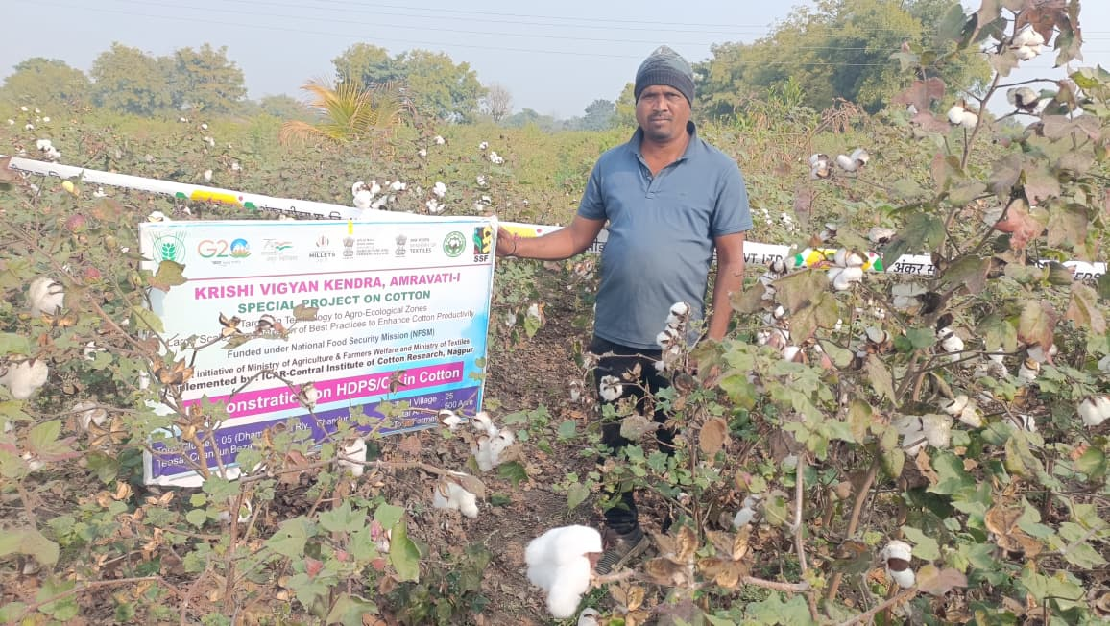
A view of Demonstration plot along with farmers while taking observation at boll bursting stage

Success story on Quality onion Production
Situation analysis/Problem statement:
In a Amravati district the total Area under Onion are 4878 ha and production from it 97853MT and the Overall average Productivity are 201 MT/ha i.e. there is wide potential to increase the production as well as productivity from the productive area .The Onion farmers also faces significant challenges including extreme price volatility, high cultivation cost of fertilizer and labor and massive post harvest losses due to poor storage infrastructure.
Plan, Implement and Support:
Name of the farmer: Mr.Asish Divakar Karalkar
Age: 33 Yrs
Education : BA
Farming Experience: 12 yrs
Village: Shirajgaon Korde Tq: Chandur railway Dist: Amravati
Cultivable land :1.60 ha
Source of irrigation: well
Crop to be taken: Mandarin orange ,Vegetables ansd Agronomical crop
The village Shirajgaon Korde comes 30 km away from centre of KVK .The Mr .Ashish Karalkar is a very Sincere and enthauznestic in its work. Mr .Karalkar come contact to KVK since 2023-24 and they join the KVK for different technical information through training, awareness programme, attain the Krishi Melawa at KVK, before to join KVK they had taken the annual income 2.00 lakh from total Cultivable area. After attending the, different programmes they set his mind to cultivate the different crop only under the guidance of KVK scientist.
Output:
Mr Karalkar attended the different skill oriented training programme which was organized by KVK and Planned under advice of SMS (Horti) selected the Onion crop .In between kvk selected the village shirajgaon korde under FLD Onion and seed of Akola safed variety provided to 15 farmers .In this programme farmers prepared the seedling and planting completed in the 2nd half of December .The nutritional fertigation provide as per soil test base under the guidance of KVK scientist. The effect of proper fertigation doses as per the growth stages , taken the yield up to 100 q from 0.20ha area, also improve the quality of the Bulb reduces the pest and diseases .The total expenditure calculated for produce was 30000/- and gross return from sale out was at Rs. 220000/-in a fluctuated rates and the Net returns. 190000/-from 0.20ha area get to farmers
Outcome:
The increasing yield with net profit from the same land and the effects that the vertical as well as horizontal spread of the farmers in that village and in surrounding village increases and interested vegetable grower visited to Mr. Karalkar field and taken the information regarding cultivation practices and also asks about the source of technology Then some farmer immediately contact to KVK and ask about the interest for production technology of vegetable cultivation at open condition.
Impact:
The overall impact of the net profit, farmers doing the work of house of Rs.0.50lakh, Renovation of Well in the field at Rs.0.50lakh.Also, Return the loan of the motor cycle and doing the vehicle free in a single installment of Rs.0.20lakh and balance 0.70 lakh fix deposited on his name for next season activity. These types of social development take place due to the additional benefits of adopting the new technologies from the KVK Scientist .The overall impact of the development; farmers status in his society as well in village level increases. They point out that the area in vegetables will be increases in a next year in our village and in surrounding villages also
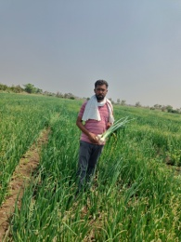 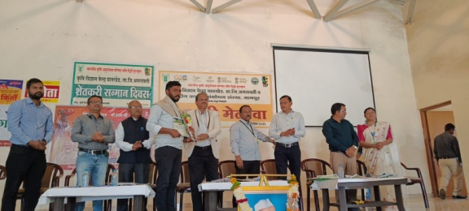 Farmers showing the crop Appreciation of Farmer for Higher onion Production
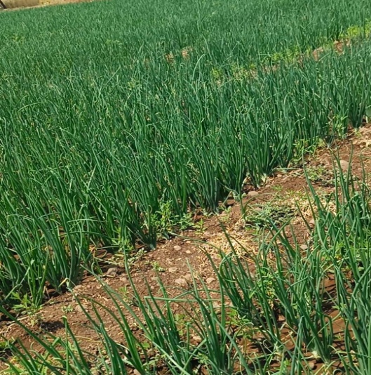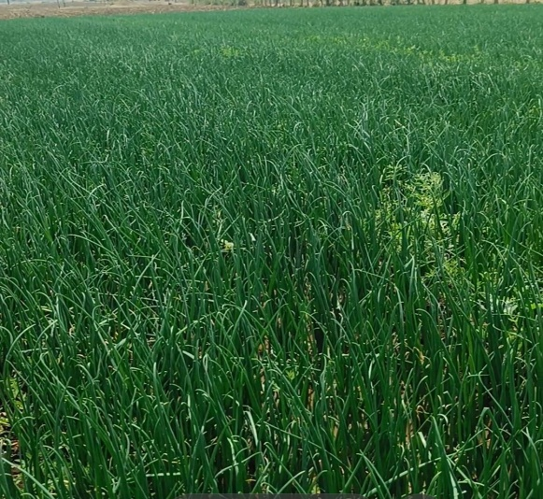
Farmer’s onion plot

Success story on Increasing the net income by growing Flower crop

Situation analysis/Problem statement:
In a Amravati district the total Area under Flowers crop are 91 ha and production from it 492 MT and the Overall average Productivity are 54.06 MT/ha i.e. there is wide potential to increase the production as well as productivity from the productive area of flower crop .The farmers also faces significant challenges including extreme price volatility, labor problems cost of fertilizer and massive post harvest losses due to poor storage infrastructure.
Plan, Implement and Support:
Name of the farmer: Mr.Satish Divakar Hude
Age: 42 Yrs
Education : 12 th
Farming Experience: 15yrs
Village: Anjanvati Tq: Dhamangaon railway
Cultivable land :0.80 ha
Source of irrigation: well
Crop to be taken: Mandarin orange ,Vegetables and Floriculture l crop
The village Anjanvati comes 31 km away from centre of KVK .The Mr .Satish Hude are very Sincere in its work. Mr .Hude come contact to KVK since 2023-24 and they join the KVK for different technical information through training, awareness programme, attain the Krishi Melawa at KVK, before to join KVK they had taken the annual income Rs. 60000/- from 0.80ha cultivable area. After attending the, different programmes they set his mind to cultivate the Flower crop only under the guidance of KVK scientist.
Output:
Mr. Hude attended the different skill oriented training programme which was organized by KVK and Planned under advice of SMS (Horti) selected the Flower crop .In between kvk selected the village Anjanvati under FLD for Gaillardia and seed of Grandiflora variety provided to 15 farmers Also ,in Kharif at its level grown Merigold and then in Rabi season he grown the Annual Crysanthemum Variety Bijali .In this programme farmers prepared the seedling and planting completed in the month of jully and November respectively .The nutritional fertigation provide as per the guidance of KVK scientist. The effect of proper fertigation doses as per the growth stages , taken the yield up to 60quintals from 0.80ha area, also improve the quality of the Flowers, reduces the pest and diseases .The total expenditure calculated for produce was 55000/- and gross return from sale was at Rs. 150000/-in a 30Rs/kg at fixed rates all over the year for all crop i.e. Merigold, Gailllardia and Crysanthemum and the Net returns. Were 105000/- from 0.80ha area get to farmers.
Production: The production details for 2025 are as fallows
Year | Crop | Total grown area in ha | Total Expenditure | Gross income | Net income | B:C ratio
2025-26 | Gallardia | 0.30(Kharif Season) | 20000 | 65000 | 45000 | 3.25
 | Merigold | 0.30(Kharif season ) | 15000 | 45000 | 30000 | 3.00
 | Crysanthemum | 0.20(Rabi Season) | 20000 | 50000 | 30000 | 2.50
 | Total | 0.80 | 55000 | 160000 | 105000 | 2.91
Outcome:
The increasing yield with net profit from the same land and the effects that the vertical as well as horizontal spread of the farmers in that village and in surrounding village increases and interested Floriculture grower visited to Mr. Hude field and taken the information regarding cultivation practices and also asks about the source of technology Then some farmer immediately contact to KVK and ask about the interest for production technology of Flower cultivation at open condition.
Impact:
The overall impact of the net profit, farmers doing the work of house of Rs.0.30akh, Renovation of Well in the field at Rs.0.10 lakh.Also, Return the loan of the motor cycle and doing the vehicle free in a single installment of Rs.0.20lakh and balance 0.30 lakh fix deposited on his name for next season activity. These types of social development take place due to the additional benefits of adopting the new technologies from the KVK Scientist .The overall impact of the development; farmers status in his society as well in village level increases. They point out that the area in Flower crop will be increases in a next year in our village and in surrounding villages also.

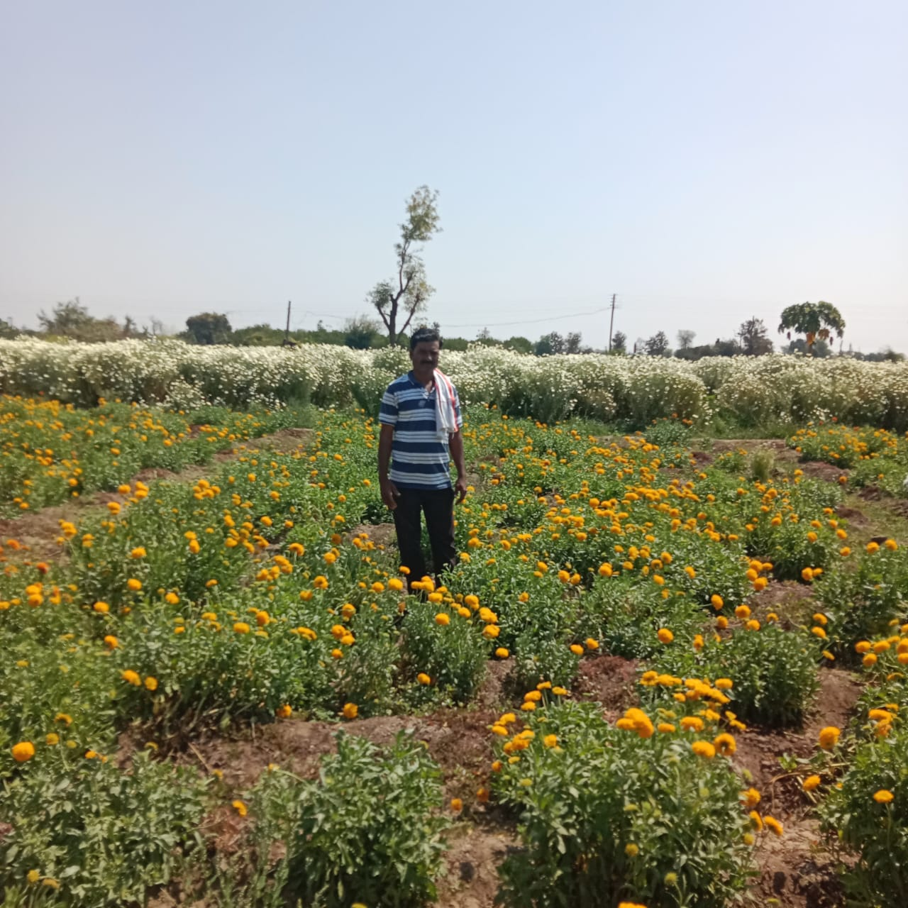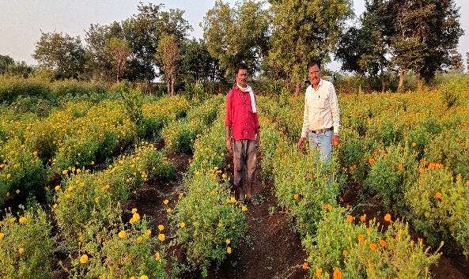
Farmer showing Gaillardia Plot KVK Scientist visited to farmers Plot

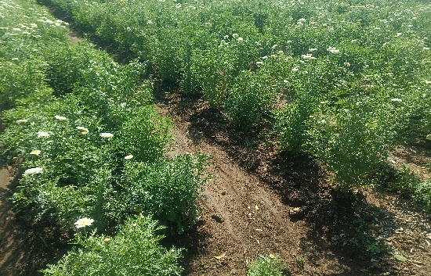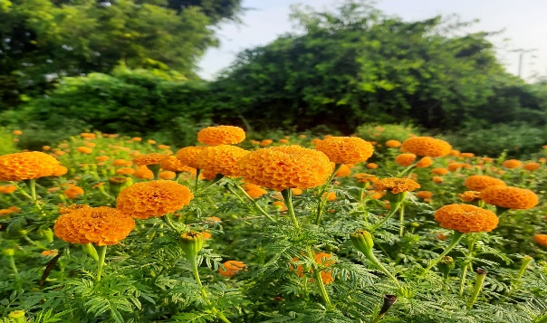
Farmers Chrysanthemum ( PDKV BIjali )Plot Farmers Merigold Plot

Sericulture Intervention by KVK – A Model of Sustainable Livelihood Improvement

1. Situation Analysis / Problem Statement
Amala is a small village in Chandur Railway taluka of Amravati district. Shri Narendra Pandurangji Nalhey (47 years), a progressive farmer from village Amala, was cultivating crops on 6 hectares of irrigated land under a traditional cropping system.
Initially, he followed conventional practices such as:
- Sowing without seed treatment (bio-fertilizers or chemicals)
- Traditional drilling method without proper spacing
- Indiscriminate use of fertilizers and pesticides
These practices resulted in:
- Low productivity
- Increased cost of cultivation
- Decline in soil health
- Reduced net returns
He also faced serious climate change challenges such as unseasonal rainfall and cloudy weather, adversely affecting crop growth and yield.
Market-related issues further aggravated the situation:
- Price fluctuation due to “low demand–high supply” conditions
- Dependence on traders/adatiyas in market yards
- Lack of direct market linkage
- Inability to generate sufficient income for family livelihood
Due to these constraints, the farmer was unable to secure sustainable income from traditional cropping despite having irrigated land resources.

2. Plan, Implement and Support
To address the above problems, the Krishi Vigyan Kendra (KVK) intervened with Sericulture-based crop diversification as an alternative livelihood model.

Activities Implemented
A. Technological Intervention
- Introduction of Mulberry cultivation on 2.25 acres
- Scientific silkworm rearing practices
- Improved mulberry varieties
- Scientific spacing and nutrient management
- Integrated pest and disease management
B. Capacity Building & Extension Efforts
KVK organized training programmes to build the farmer’s knowledge and skills in scientific sericulture practices. Regular technical advisories, field visits, and diagnostic support were provided for timely problem-solving. Exposure visits to successful sericulture units and farmer–scientist interaction meetings further strengthened confidence and ensured effective technology adoption.
C. Critical Input Support
The sericulture unit was successfully established through convergence between KVK and the Sericulture Department, Amravati. The department provided quality mulberry saplings, silkworm seed supply guidance, technical literature, and regular consultancy support. KVK facilitated farmer motivation, training, and continuous follow-up with the department to avail scheme benefits and ensure timely input support.

3. Output

The farmer successfully completed 11 silkworm rearing batches within one year. Through scientific mulberry cultivation and improved silkworm rearing practices, he generated a total income of ₹7, 12,629.00. The total cost of production was ₹2, 49,421.00, resulting in a substantial net income of ₹4, 63,208.00. This significant increase in profitability clearly demonstrates the economic viability of sericulture as a sustainable and remunerative enterprise.

Tangible Results:
- Significant increase in farm profitability
- Reduced dependency on traditional cropping
- Regular and assured income generation
- Improved productivity of mulberry and silkworm rearing
- Better crop management and reduced indiscriminate chemical usage
In recognition of his achievements, the farmer received the Agro Vision Progressive Farmer Award 2025 at the hands of Hon’ble Shri Nitin Gadkari, Minister, Government of India.

4. Outcome

Horizontal Spread
- 05 farmers from Amala village started sericulture units after observing his success
- Farmers from neighboring villages visited the unit for guidance
- Expansion of sericulture area in nearby villages

Economic & Social Outcomes
- Improved family income and financial stability
- Creation of additional on-farm employment
- Reduced dependency on traders
- Enhanced self-reliance

Technological Outcomes
- Adoption of scientific mulberry cultivation practices
- Reduction in chemical inputs
- Improved quality and quantity of cocoon production
Estimated Net Annual Gain: ₹ 4,63,208.00 per year from 2.25 acres

5. Impact (Macro-Level Evidence)

Economic Impact
- Promotion of crop diversification in Amravati district
- Contribution to district sericulture production
- Improved farm-level income contributing to rural economy

Social Impact
- Improved education opportunities for children
- Increased social recognition and status
- Farmer developed as a Role Model and Resource Farmer

Environmental Impact
- Climate-resilient farming through crop diversification
- Better utilization of irrigated land
- Sustainable income generation system

Institutional Impact
- Strengthening of sericulture-based livelihood systems
- Development of farmer-to-farmer extension model

Conclusion
The sericulture intervention transformed Shri Narendra Pandurangji Nalhey from a traditional crop farmer facing climate and market uncertainties into a successful, diversified entrepreneur.
Within one year, adoption of scientific mulberry cultivation and silkworm rearing generated a net income of ₹ 4.63 lakh, improved livelihood security, inspired neighboring farmers, and established a sustainable and climate-resilient farming model in Amala village.
This case stands as an exemplary KVK-led technology adoption success story demonstrating economic viability, sustainability, and social empowerment.
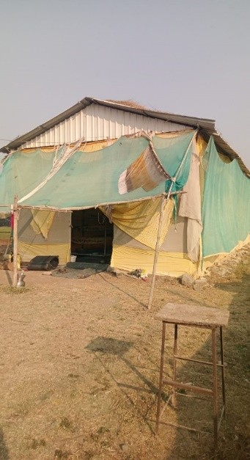 | 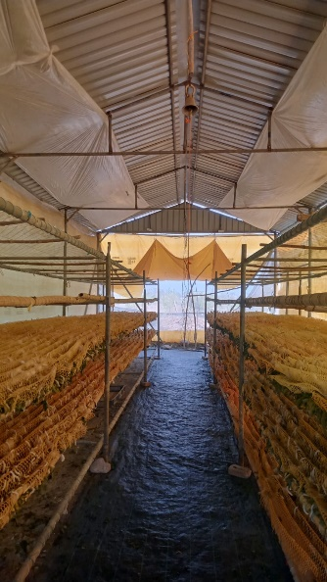 | 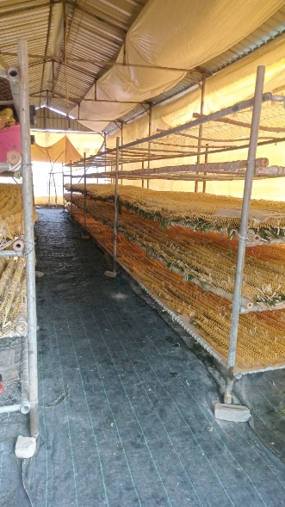 | 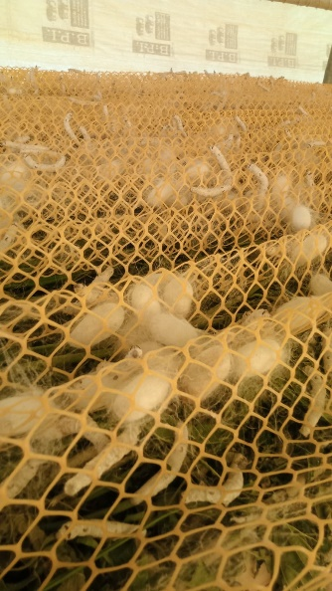
Rearing unit of Sericulture by farmer
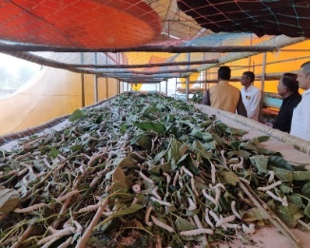 | 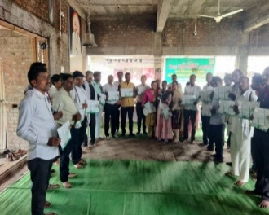 | 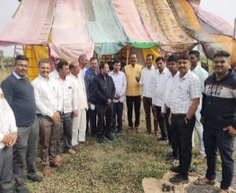 | 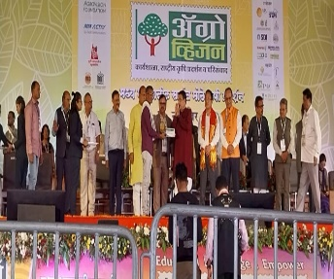
Production of Sericulture | Training on sericulture | Exposure visit at farmers unit | Agro vision Progressive farmers Award 2025 received at the hands of Hon’ble Shri Nitin Gadkari, Minister, , Government of India

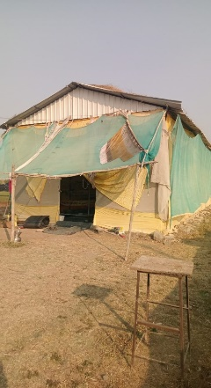
Integrated Farming and Fodder Entrepreneurship Enhancing Farmers’ Income
Name of Farmer: Mr. Rishikesh Sharadrao Junghare
Village: Belaj
Taluka: Chandur Bazar
District: Amravati
State: Maharashtra
Land Holding: 6 Acres

1. Situation Analysis / Problem Statement
Mr. Rishikesh Sharadrao Junghare was practicing a traditional mono-cropping system on his 6 acres of land, cultivating soybean, cotton, pigeon pea, and chickpea. Although irrigation facilities were available and livestock potential existed, the farm remained largely seasonal and dependent on conventional practices.
The farming system was characterized by high input costs, low net returns, and frequent market price fluctuations. Income was primarily dependent on seasonal harvests, resulting in financial instability throughout the year. Limited diversification and inadequate recycling of farm resources further restricted profitability and sustainability.
Thus, there was a clear need for a diversified Integrated Farming System (IFS) that could ensure regular income, reduce production and market risks, and improve resource-use efficiency.

2. Plan, Implementation and Support
After approaching Krishi Vigyan Kendra (KVK), Amravati, farm assessment was conducted and an Integrated Farming System model was introduced.

Major Interventions:

A. Crop Diversification
- Introduction of Papaya (1 acre – 600 plants) as a high-value horticulture crop
- Adoption of improved crop management practices

B. Fodder Entrepreneurship (2 Acres)
Improved high-yielding fodder varieties introduced:
Napier, Super Napier, Indonesian Napier, Phule Gunwant, Phule Jaywant, American 5G, Bullet 4G, Australian Red, Kenya, Bengal Half Red, Maize Cross MCM, and BNH-11.
KVK provided technical guidance on nursery raising, planting material production, spacing, nutrient management, and scientific cultivation. Marketing strategy guidance was also provided. The farmer adopted self-marketing and developed interstate linkages in Gujarat, Madhya Pradesh, Chhattisgarh, Maharashtra, Telangana, and Andhra Pradesh.
Annual Income from Fodder Planting Material:
Gross: Rs 6, 50,000
Expenditure: Rs 2, 25,000
Net Income: Rs 4, 25,000

C. Crop Production Income
Total Cost of Production: Rs 2, 30,000
Gross Income: Rs 4, 39,500
Net Income: Rs 2, 09,000
Major contributor: Papaya (Net ₹1, 50,000)

D. Dairy Enterprise
07 Buffalo + 1 Cow
Gross Income: Rs 8, 64,000
Cost: Rs 6, 20,000
Net Income: Rs 2, 44,000

E. Vermicomposting & Bio-products
- Vermicompost (20 ton/year)
- Vermiculture (180 kg/year)
- Vermiwash (600 lit/year)
- Gauri products (18,000 pieces/year)
Total Gross Income: Rs 3, 92,000
Total Expenditure: Rs 1, 20,000
Net Income: Rs 2, 72,000

3. Output
The Integrated Farming System resulted in diversified income streams and enhanced productivity.

Overall Annual Financial Performance:
Enterprise | Gross Income (Rs) | Expenditure (Rs) | Net Income (Rs)
Fodder | 6,50,000 | 2,25,000 | 4,25,000
Dairy | 8,64,000 | 6,20,000 | 2,44,000
Vermicompost & Bio-products | 3,92,000 | 1,20,000 | 2,72,000
Crop Production | 4,39,500 | 2,30,000 | 2,09,000
Total | 23,45,500 | 11,95,000 | 11,50,000
The farm income increased substantially to ₹11.5 lakh net annually.

4. Outcome
The adoption of the Integrated Farming System resulted in the development of multiple income sources, reducing dependency on a single seasonal crop. Diversification through horticulture, fodder entrepreneurship, dairy, and bio-input production significantly increased farm profitability and ensured year-round income stability.
The incorporation of vermicomposting improved soil health and reduced reliance on external chemical inputs. Efficient recycling of crop residues and dairy waste enhanced resource-use efficiency and lowered production costs. The diversified enterprises also generated additional on-farm employment opportunities, strengthening livelihood security.
The successful establishment of fodder entrepreneurship with interstate self-marketing further expanded income avenues and market reach. Overall, the integrated farming model proved economically viable, sustainable, and resilient to production and market risks.

5. Impact

Economic Impact
Significant enhancement in annual income (Rs11.5 lakh net) and improved financial security.

Social Impact
Farmer became a role model in the region and inspired neighbouring farmers to adopt integrated farming.

Environmental Impact
Improved soil fertility, reduced chemical dependency, and better resource recycling.

Institutional Impact
The remarkable success of the Integrated Farming System model led to strong institutional recognition. Mr. Rishikesh Sharad Rao Junghare was recommended by Krishi Vigyan Kendra (KVK), Amravati as a Model Farmer for adoption of diversified and sustainable farming practices.
In recognition of his innovative approach and outstanding performance, he was honoured with the Dr. PDKV Idol Farmer Award by Dr. Panjabrao Deshmukh Krishi Vidyapeeth. This recognition not only validated the effectiveness of the integrated farming model but also strengthened his role as a resource farmer and inspiration for other farmers in the region.

Conclusion
The adoption of an Integrated Farming System transformed Mr. Rishikesh Junghare’s farm from a traditional mono-cropping system into a diversified, profitable, and sustainable enterprise model.
The integration of horticulture, fodder entrepreneurship, dairy, and bio-input production enhanced annual net income to ₹11.5 lakh, reduced farming risks, and created a replicable model for farmers in similar agro-climatic regions.

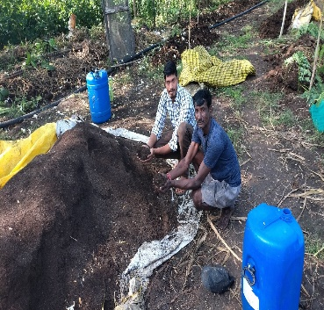 | 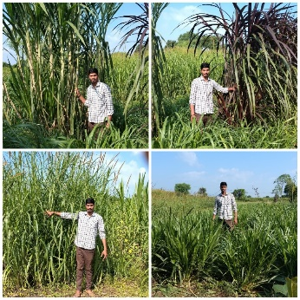 | 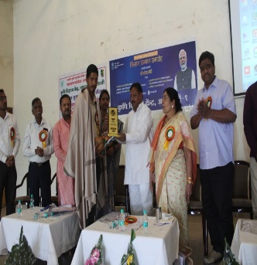 | 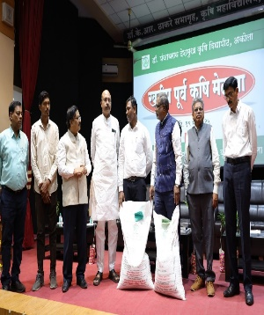
Vermicompost unit of farmer | Fodder unit of farmer | Mr. Balwant Wankhade, Member of Parliament from Amravati, felicitated the farmer at the Krishi Vigyan Kendra (KVK), Amravati, in recognition of his outstanding contribution and achievements in agriculture. | Honoured with the Dr. PDKV Idol Farmer Award, presented by Dr. Panjabrao Deshmukh Krishi Vidyapeeth, Akola, in recognition of outstanding achievements in agriculture.

